caTissue C3PR Integration Design

V 0.0.3

11/12/2010

Authors | Carlos E. Perez
Reviewers
Architecture Inception Team

DOCUMENT CHANGE HISTORY
Version Number | Date | Contributor | Description
0.0.1 | 08/17/2010 | Carlos Perez | Initial version
0.0.2 | 10/14/2010 | Carlos Perez | Updated based on discussions with Ram, Monish, Rakesh
0.0.3 | 11/12/2010 | Carlos Perez | Updated flow to reflect new Services

Table of Contents
C3PR Integration 3
Create Study 3
Register Subject 4
System Flow 6
Behavior 6
Components 7
caTissue Registration Consumer Service 7
caTissue Subject Registration Service 7
Message to Model Mapping 7
Participant Mapping 7
Study Mapping 12

C3PR Integration

In the C3PR integration, subjects are registered to studies through the C3PR web interface, and C3PR broadcasts a registration notification that includes key identifiers of the subject. For clinical trials that contain a biospecimen collection component, studies in C3PR will be linked to collection protocols in caTissue through COPPA services. When subjects are registered in C3PR, the registration notification will be broadcasted to caTissue, and this participant will be registered to the associated collection protocol.

When a Patient is registered to a study then the message should convey the consent signature date and registration date.

Consent Types may need to be aligned. CDE Browser (i.e. https://cdebrowser.nci.nih.gov/CDEBrowser/ 2974066 ) provides the following:

Biomarker
Correlative Study
Donor
Pharmacokinetics
Quality of Life
Record Release
Screening
Standard Care
Clinical Study Participation
Tissue Collection

Will there be a synchronization capability that tells C3PR to resend all previously sent Registrations and Studies?

Pre-registration information notification is important. In the event of a subject not being eligible, a notification needs to be sent to caTissue to discard the specimen.

Create Study

Brief Description | A study definition can be sent from C3PR to the other applications. This can either be a manually entered study or a study retrieved from the NCI Enterprise Services. Once the information is complete and correct in C3PR, a Create Study message can be broadcasted to the other modules in the Suite. A record of the study is kept in each module, where it can be viewed, augmented, or updated, as needed.
Primary Actor(s)
  C3PR | Site Coordinator (to create the study), Study Coordinator (to open and broadcast the study to the other modules)
Secondary Actor(s) | Admin
Preconditions | Before creating a study in the Suite, it is necessary to ensure that the Investigators and organizations associated with the study being broadcast are already created in each of the modules, that the assigned identifier (typically, the CTEP identifier) is not null, and that the assigned identifier is identical between the modules. This prerequisite is important especially to caAERS and to PSC.
Basic Flow of Events | - The user selects the Create Study option.  - The user complete all the steps and required fields for setting up the study. For detailed instructions on how to create a study in the Participant Registry application, see the C3PR End User Guide.  - Once the study data have been completed and saved, a Study Coordinator in C3PR initiates the replication of the data to the other applications.  - The Study Coordinator opens the study by selecting Manage Study, and then broadcasts the study data by clicking the Broadcast Study.
Post Conditions | The status of the broadcast is updated on the screen. The following status messages may appear:
  Status | Meaning
  Message Send | The study message has been sent to the other modules. Confirmation not yet received.
  Message Send Confirmed | The study message has been sent and confirmed. The study has been set up in each module.
  Message Send Failed | The message failed. The study was not set up in any of the other modules.
Alternate Flow | None.
Special Requirements | None.

Register Subject
Use Case Model
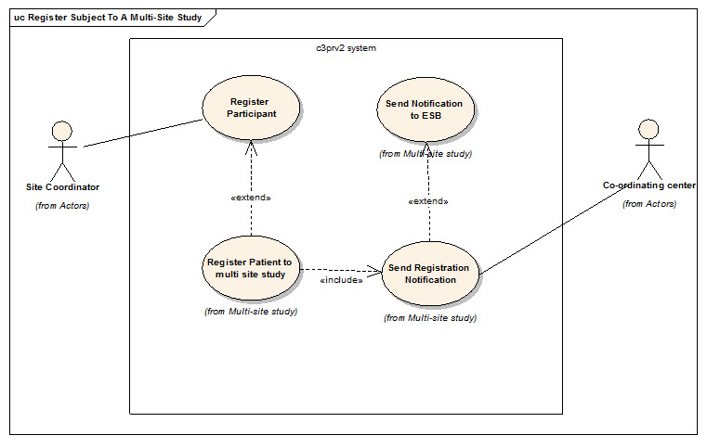

Brief Description | A new patient must be registered to a study. The Clinical Research Associate (CRA) verifies that the subject meets the eligibility criteria and enters the required information into the Suite via the Patient Registry application and the data are saved to the database. Once the patient has been assigned to an epoch, the CRA initiates Register Subject message, including epoch start date and name, to the other Suite applications which then record the participant information and epoch. The message to the Study Calendar automatically triggers the generation of the study calendar for that subject. The CRA reviews the schedule of upcoming visits and the associated activities for that subject.
Primary Actor(s)
  Application | Role
  C3PR | Registrar
  PSC | Subject Coordinator
Secondary Actor(s) | Admin
Preconditions | Before subject registrations can be successfully broadcasted from C3PR to the other applications in the Suite, a number of prerequisites must be met. These include the following:  - The study must be already be created in each module  - In PSC, the study template must be created and released. The user registering the subject must be authorized to assign subjects to the study.
Basic Flow of Events | - The user registers the subject to the study.  - The user completes data entry and and saves the data in the Participant Registry.  - The subject is enrolled into the study.  - Replication of the subject's registration to the other applications is performed.
Post Conditions | The status message of the broadcast will be updated. If the message does not change, click the refresh button to check on the status. The following status messages may appear:
  Status | Meaning
  Message Send | The registration message has been sent to the other modules. Confirmation not yet received.
  Message Send Confirmed | The registration message has been sent and confirmed. The registration has been processed in each module.
  Message Send Failed | The message failed. The registration was not completed in any of the other modules.
Alternate Flow | None.
Special Requirements | None.

System Flow
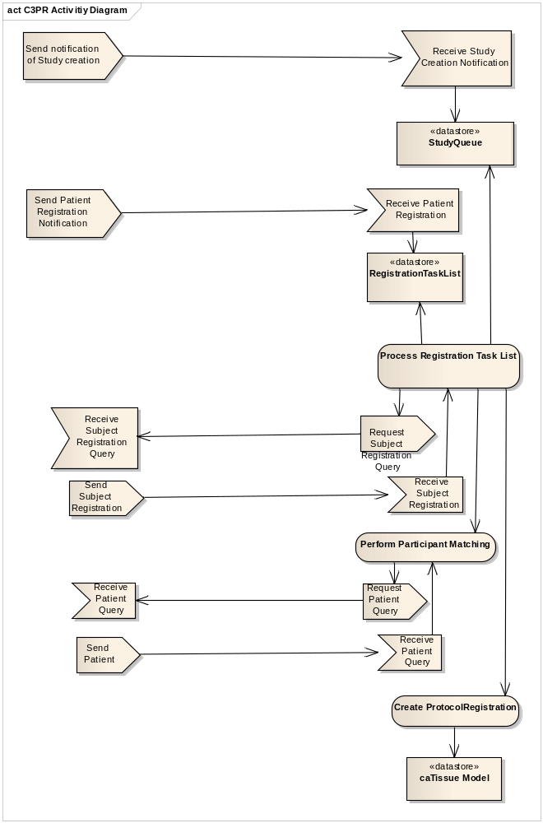
Figure: Activity Diagram, first column is C3PR and second column is caTissue

Behavior

- On receipt of a Study from C3PR
  - caTissue will accept this message (). Study NCI CTRP -> Open Issue (non cancer trial)
  - May exist in COPPA
- On receipt of a Subject Registration
  - caTissue will queue the information

  - Lookup CollectionProtocol (Study) from Internally / NCI CTRP
  - Lookup up the Participant, if none is found create a new Participant.
  - caTissue will create a new ProtocolRegistration.
  - Assign the Participant to the ProtocolRegistration.
  - Assign the ProtocolRegistration to the CollectionProtocol.

Open Issues.

- Patient information… Source is C3PR… Subject Management Service (Available)
- C3PR missing information such as consent signature date(x),registration date(x),consent type (examples) may need to be addressed. (Nice to have)
- C3PR epoch types may need alignment with a codesystem. (Nice to have) (provide list of type a s)
- caTissue will queue requests and leverage Participant matching.
- Not all C3PR attributes have a corresponding caTissue attribute to map to. ( Not a major concern )
- caTissue CSM Role Model needs alignment.

Components

caTissue Registration Consumer Service

Details

caTissue Subject Registration Service

Details

Message to Model Mapping

Note: Consent Type will be tabled for a future release.

Participant Mapping
Note: CollectionProtocolRegistration is created when Participant is registered with the Study.

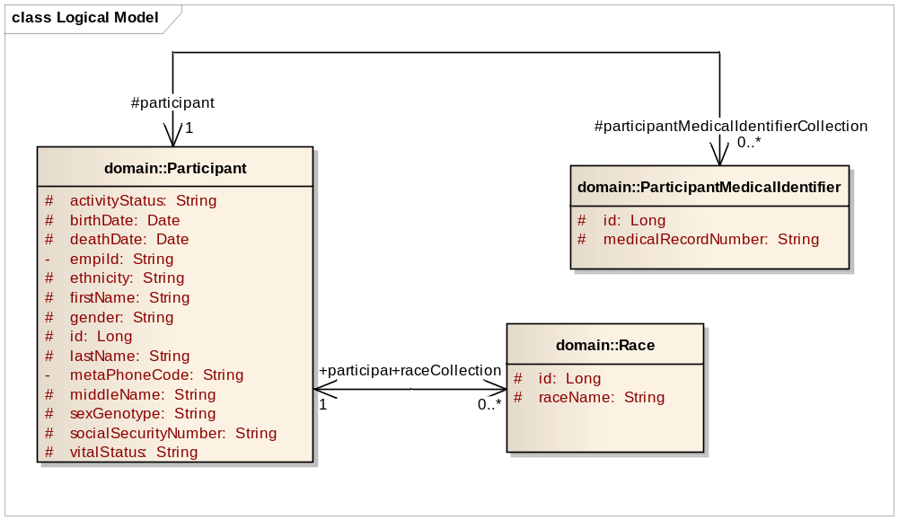

Figure. caTissue Participant Model
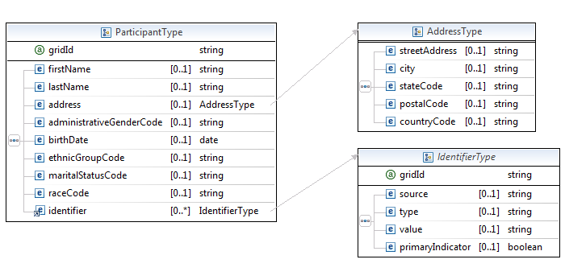

Figure C3PR Registration Message

Participant Mapping

C3PR Element | caTissueModel
ParticipantType/firstName | Participant.firstName
ParticipantType/lastName | Participant.lastName
ParticipantType/administrativeGenderCode | Participant.gender
ParticipantType/birthDate | Participant.birthDate
ParticipantType/ethnicGroupCode | Participant.ethnicity
ParticipantType/martialStatusCode
ParticipantType/raceCode | Race.id, Race.raceName
gridId | Participant.id
ParticipantType/address/streetAddress
ParticipantType/address/city
ParticipantType/address/stateCode
ParticipantType/address/postalCode
ParticipantType/address/countryCode
ParticipantType/identifier/source | Site.name
ParticipantType/identifier/type |  | ?
ParticipantType/identifier/value | ParticipantMedicalIdentifier.medicalRecordNumber
ParticipantType/identifier/primaryIndicator |  | ?

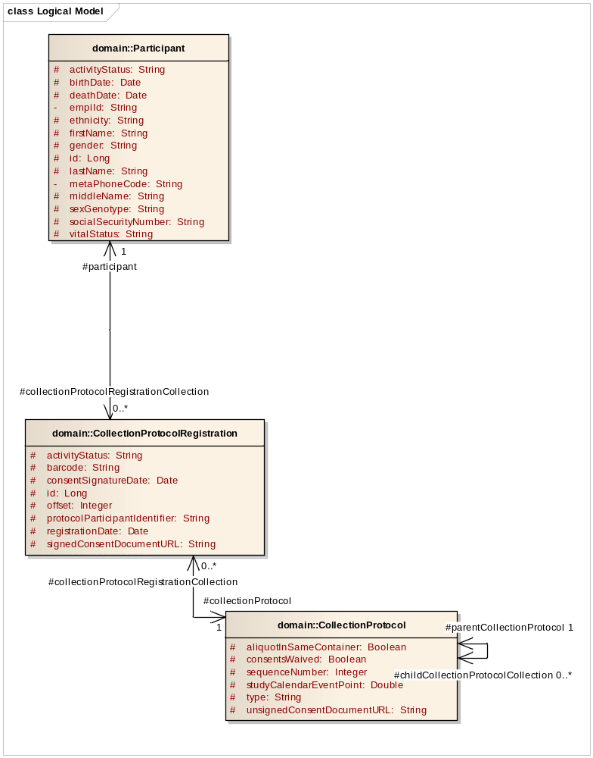

Figure. caTissue Registration

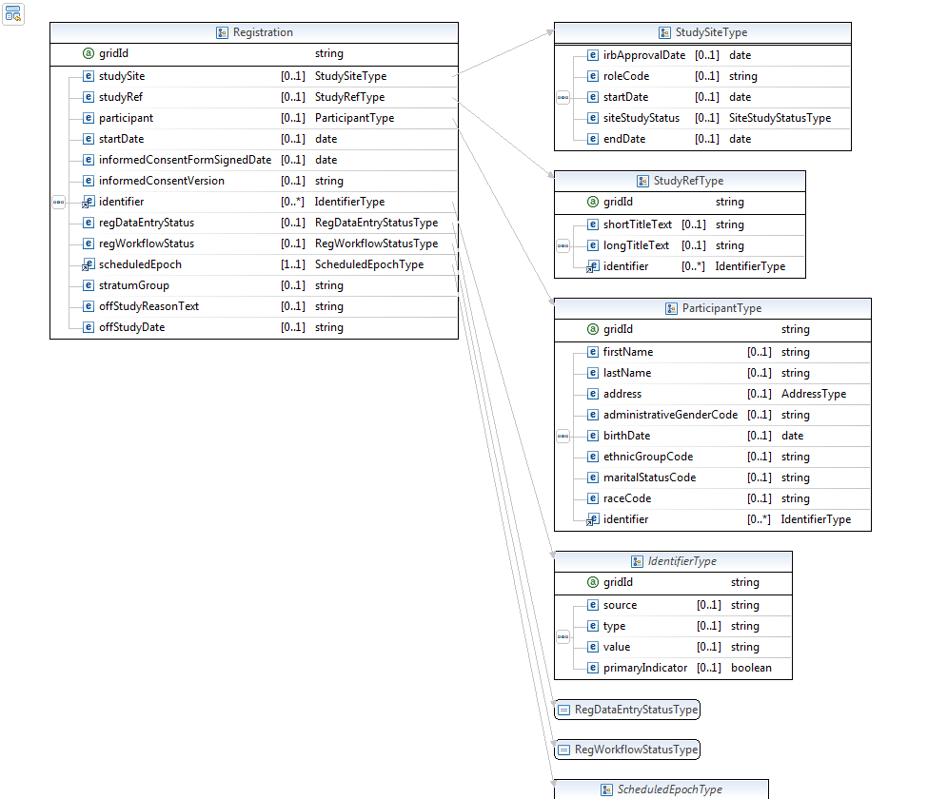

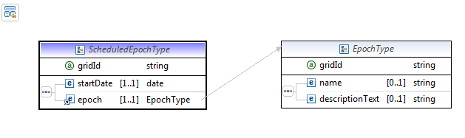
Registration Mapping

C3PR Element | caTissueModel
Registration/studySite
Registration/studyRef
Registration/participant | CollectionProtocolRegistration.participant
Registration/startDate | CollectionProtocolRegistration.registrationDate
Registration/informedConsentFormSignedDate | CollectionProtocolRegistration.consentSignatureDate
Registration/informedConsentVerion
Registration/identifier | CollectionProtocolRegistration.id
Registration/regDataEntryStatus
Registration/regWorkflowStatus | CollectionProtocolRegistration.activityStatus
Registration/scheduleEpoch | Used by PSC | ?
Registration/stratumGroup
Registration/offStudyReasonText
Registration/offStudyDate

Study Mapping

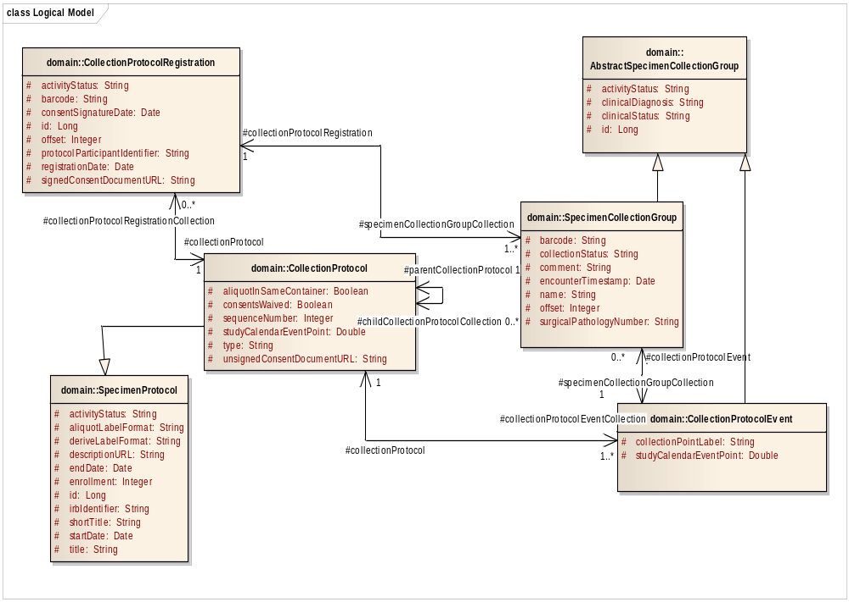
Figure. caTissue CollectionProtocol

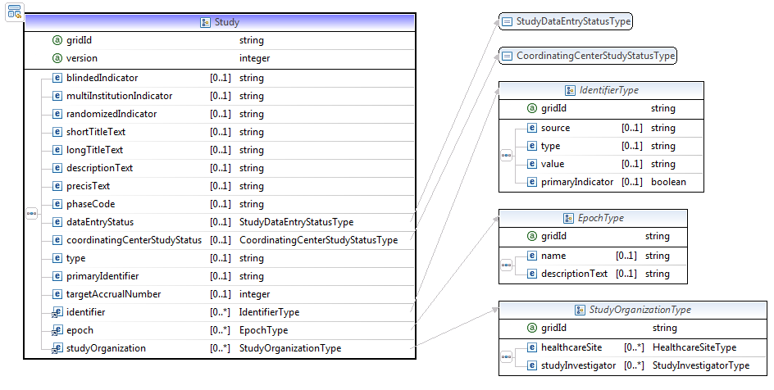
Figure. C3PR Study

C3PR Study | caTissue
Study/bindedIndicator
Study/multiInstitutionIndicator | Not Used
Study/randomizedIndicator
Study/shortTitleText | SpecimenProtocol.shortTitle
Study/longTitileText | SpecimenProtcol.title
Study/descriptionText
Study/precisText
Study/phaseCode
Study/dataEntryStatus
Study/coordinatingCenterStudyStatus
Study/type | CollectionProtocol.type
Study/primaryIdentifier | SpecimenProtocol.irbIdentifier
Study/targetAccrualNumber
Study/identifier | SpecimenProtocol.irbIdentifier
Study/epoch | This is used by PSC for later modification
Study/studyOrganization | This is likely linked to the COPPA Organization

